MINUTES OF INCEPTION SEMINAR

“Urban resilience and adaptation for India and Mongolia: curricula, capacity, ICT and stakeholder collaboration to support green & blue infrastructure and nature-based solutions – URGENT”

Coordinator: National university of Mongolia
Participants: Mongolian University of Life Sciences
Khovd University
Urban Planning and Research Institute
National Garden Park of Ulaanbaatar
Centre for faculty development and digital learning, NUM
Insitute for sustainable development, NUM
Department of Geography, NUM

Date: 2021.04.23
Venue: Online
Issues discussed:
- Introduced the project to stakeholders
- Duty and responsibilities of the project partners
- The project templates and its usage
- Explained the financial rules and how to prepare financial report
- Technical report and its supporting documents, how to prepare it
- E-course development, sharing, not overlapping, accessibility, review, supporting documents
- Open issues

Procedure:
Inception seminar started at 10 am as scheduled, over Zoom, and lasted till 4:30 pm. The agenda and list of participants are given in Annex 1 and Annex 2.
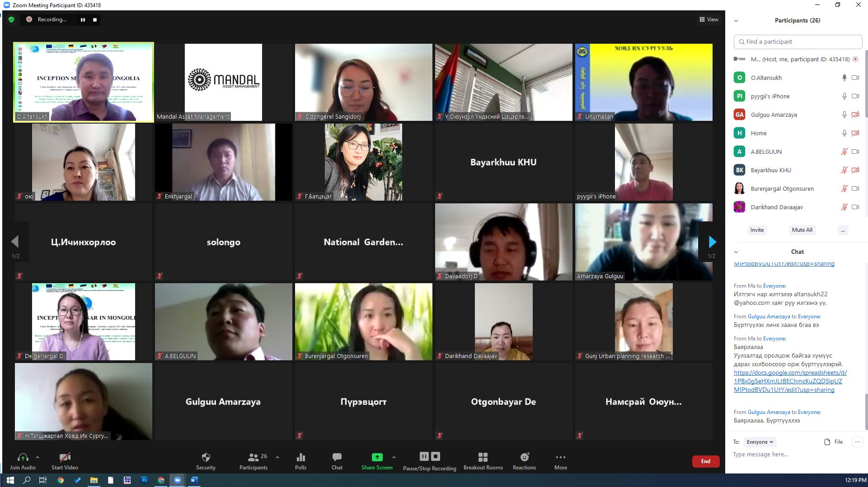
Outline:
- Introduction of participants
- Presentations by partners
- Discussions
- Decisions and intended activities
- Next meeting date

- Introduction of participants
A total of 27 participants representing 5 partner organizations participated in the seminar. Their names and information are given in Annex 2.

- Presentations by partners
- “Introduction to the URGENT project” by O.Altansukh, NUM
- “ERASMUS+ projects at the NUM” by Sh.Mendbayar, NUM
- “URGENT project duties and involvement of MULS” by D.Delgerjargal, MULS
- “URGENT project duties and involvement of KHU” by B.Bayarkhuu, KHU
- “E-learning platform at NUM” by S.Otgontsetseg, NUM
- “URGENT project duties and involvement of UPRI” by B.Ariunjargal, UPRI
- “URGENT project duties and involvement of NGP” by T.Enkhzul, NGP
- “Curriculum preparation, and accreditation procedure at NUM” by N.Purevtsogt, NUM
- “Use of project logos, templates etc. in appropriate manner” by O.Altansukh, NUM
- “The project activities and its reporting” by O.Altansukh, NUM
- “The project budget, finance and its reporting” by O.Altansukh, NUM
- “URGENT e-course development” by B.Bayarkhuu, KHU

- Discussions
- Following each presentation, there were Q&A sessions from the presenter.
- Major discussions were on the procedures related to the curriculum development, how to prevent overlapping of the topics and subjects.
- Also, main points discussed were regarding how to create the time sheets, record the activities of project, and compile reports etc.

- Decisions and intended activities
Based on the discussion the following decisions and intended activities are to be implemented within project framework. These are:
- Developing E- field class /lead by MULS/
- Conduct joint research on common topic, e.g. Community based urban environmental management
- Create E-science platform /in collaboration with UPRI research unit/
- Co-supervising graduate students /by 3 universities/
- Sector interactive platform partnership /lead by KHU/
- Inventory and assessment of urban green and blue infrastructure /lead by NUM/
- MOOC e-teaching requirement /lead by NUM/
- Provide case studies for e-classes /by UPRI/
- Short training by universities for professionals from UPRI and NGP
- Comparative study of man-made and natural landscape /lead by NGP/

- Next meeting date
The meeting will be organized, annually during the project period.

Annex 1: The agenda

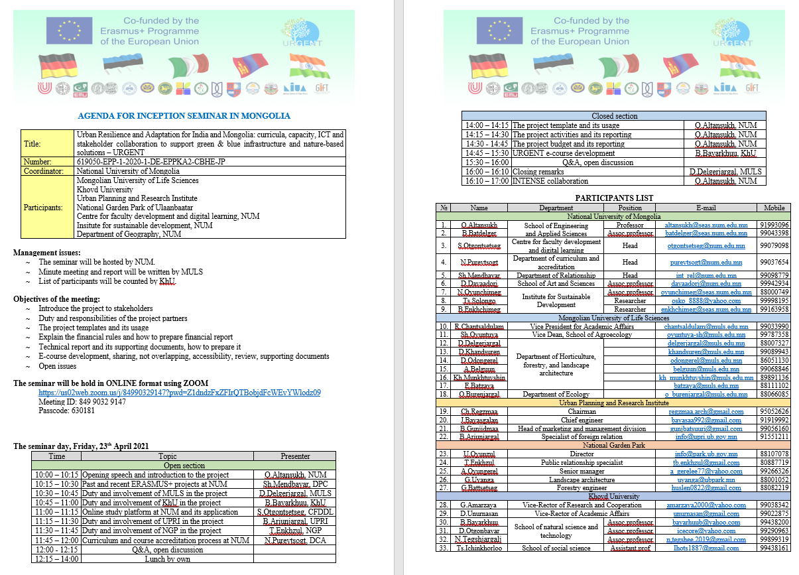

Annex 2: List of the participants

№ | Organization | Name | Position | E-mail | Mobile
1 | National University of Mongolia | O.Altansukh | National coordinator | altansukh@num.edu.mn | 91993096
2 | National University of Mongolia | Ts.Solongo | participant | osko_8888@yahoo.com | 99998195
3 | National University of Mongolia | Sh.Mendbayar | participant | int_rel@num.edu.mn | 99098779
4 | Urban planning and research institute | B.Gunjidmaa | Coordinator | info@upri.ub.gov.mn | 99056160
5 | National University of Mongolia | Otgontsetseg S | participant | otgontsetseg@num.edu.mn | 99079098
6 | Mongolian University of Life Sciences | S.Odongerel | participant | odongerel@muls.edu.mn | 86051130
7 | Khovd state university | D. Otgonbayar | participant | od88576@gmail.com | 99290963
8 | Khovd state university | В.Вayarkhuu | coordinator | bayarhuub@yahoo.com | 99438200
9 | Khovd State University | D.Unurnasan | co-coordinator | unurnasan@khu.edu.mn | 99022875
10 | Mongolian University of Life Sciences | O.Burenjargal | participant | o_burenjargal@muls.edu.mn | 88066085
11 | Urban Planning and Research Institute | B.Ariunjargal | participant | updi.ub@gmail.com | 91551211
12 | National University of Mongolia | D.Davaadorj | participant | davaadorj@num.edu.mn | 99942934
13 | Khovd State University | N.Tegshjargal | participant | ntegshee.2019@gmail.com | 99899319
14 | National University of Mongolia | N.Purevtsogt | Presenter | purevtsogt@num.edu.mn | 99037654
15 | National garden park | T.Enkhzul | participants | tb.enkhzul@gmail.com | 80887719
16 | Mongolian University of Life Sciences | Sh.Oyuntuya | participant | oyuntuya-sh@muls.edu.mn | 88025808
17 | Mongolian University of Life Sciences | Kh.Munkhtuvshin | participant | kh_munkhtuvshin@muls.edu.mn | 89891136
18 | Khovd State University | D. Darikhand | Participant | darikhand89@gmail.com | 99478930
19 | Mongolian University of Life Sciences | D.Delgerjargal | Coordinator | delgerjargal@muls.edu.mn | 88007327
20 | Mongolian University of Life Sciences | A.Belguun | Participant | belguun@muls.edu.mn | 99068846
21 | National University of Mongolia | N.Oyunchimeg | Participant | oyunchumeg@seas.num.edu.mn | 88000749
22 | National garden park | A.Oyungerel | Participant | oadilbish17@gmail.com | 99236326
23 | National garden park | G.Battsetseg | Participant | huslen0822@gmail.com | 88082219
24 | Khovd State University | G.Amarzaya | Participant | gulguuamarzaya@khu.edu.mn | 99038342
25 | Khovd State University | Ts.Ichinkhorloo | Paricipant | ihots1887@gmail.com | 99438161
26 | Mongolian University of Life Sciences | D.Khandsuren | Paricipant | khandsuren@muls.edu.mn | 99089943
27 | Mongolian University of Life Sciences | E.Batzaya | Paricipant | batzaya@muls.edu.mn | 89111102

Annex 3: Presentation by partners

